Exercise 1 rory lange

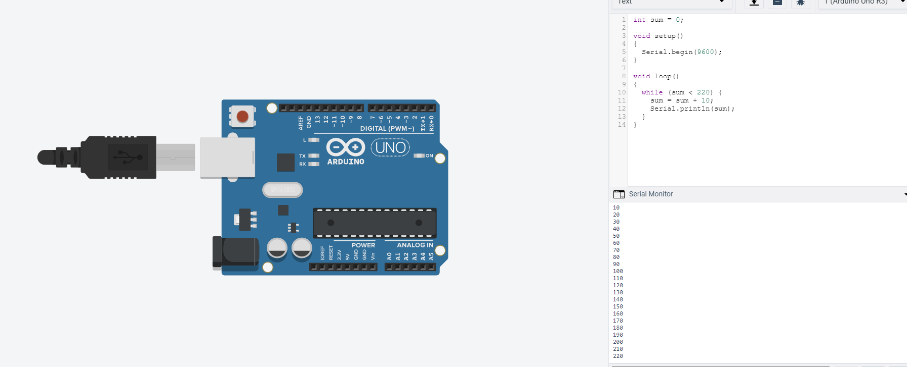

Exercise 2

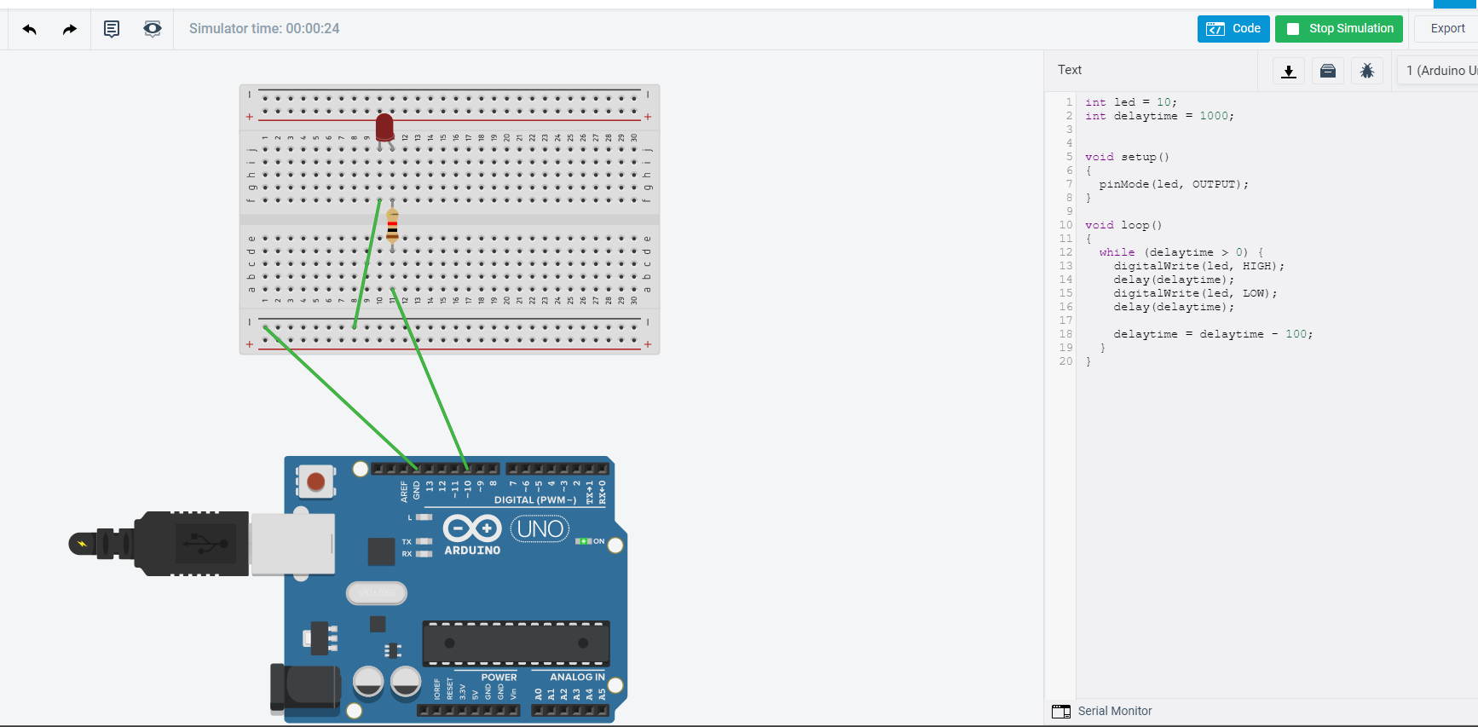

Exercise 3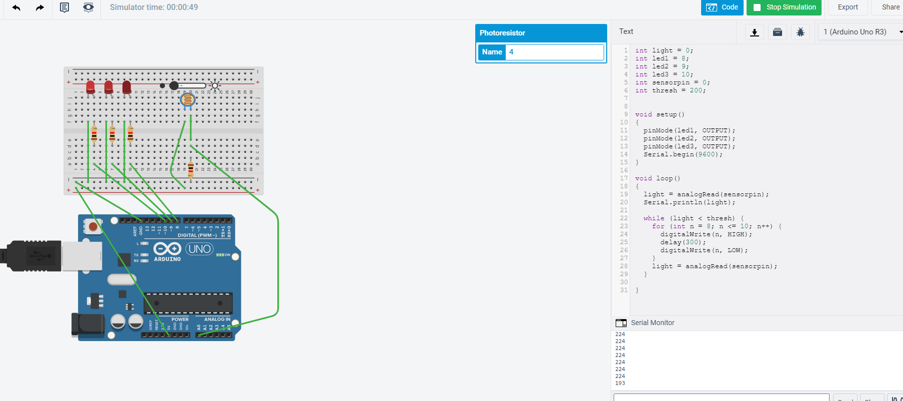

Exercise 4

|  |  |  |
| --- | --- | --- |
| A | B | Y |
| 0 | 0 | 0 |
| 0 | 1 | 1 |
| 1 | 0 | 0 |
| 1 | 1 | 1 |

|  |  |  |
| --- | --- | --- |
| A | B | Y |
| 0 | 0 | 1 |
| 0 | 1 | 0 |
| 1 | 0 | 1 |
| 1 | 1 | 0 |

|  |  |  |
| --- | --- | --- |
| A | B | Y |
| 0 | 0 | 1 |
| 0 | 1 | 0 |
| 1 | 0 | 1 |
| 1 | 1 | 0 |